## **TABLEAU CATEGORIZING FIELDS**

## **• Measures:** The quantitative values and can be aggregated. For example, sum, average, median, count, minimum, maximum, percentile, standard deviation, and variance values are the aggregated Measures. When dragging the measure to the worksheet, the data is automatically aggregated as a sum as a default setup.

## **• Dimensions:** The qualitative values and can be used to describe the data with more details. For example, product names and production dates can be considered as Dimensions. They are typically used to categorize the data.

## **• Discrete:** The values are distinct and separate from each other. It can be both Measures and Dimensions. It is shown as a blue pill in Tableau. For example, the defect event of a product (Yes or No) or the color of the product (blue and red) can be Discrete.

## **• Continuous:** The values are not distinct and can be divided into smaller fractional and decimal values. It can be both Measures and Dimensions. It is shown as a green pill in Tableau. For example, the weight, height, width, and length can be Continuous.

## Tableau IDE Features and Functions

### Tableau Start Page

Open the Tableau Public apps. A window with three panes will be shown similar to figure below.

The first pane (number 1), is list of data sources allowed for Tableau Public. For Tableau Desktop, you will have more data sources on both section (To a File and To a Server).

The second pane, depicted as number 2, is where all previous saved work is shown. It will show list of workbook or dashboard developed and save sorted by date descending (last save shown first). You can also open a dashboard that was saved in Tableau Public by click on the hyperlink on the top-right of the panel.

The third pane, depicted as number 3, is where you learn about Tableau and get to see the latest and chosen Viz.

### Data Source Screen

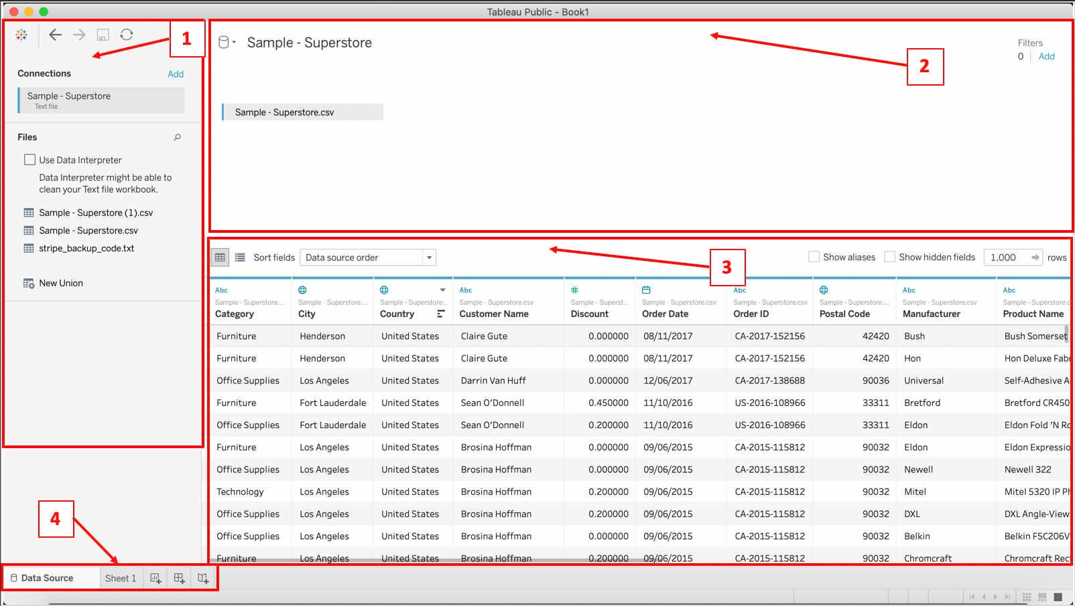

Once Tableau successfully connected to a data source, similar screen as above will appear on your screen. Detail on connecting to data source is described in Chapter 3.0, Section 3.1.

In the first pane, depicted as number 1, is called the **Left Pane**. It shows the list of connected data source and the content of the data source. If you are connecting to a database, then, a list of tables is shown. For file-based, list of sheets or data structures are shown.

The second pane is where tables or sheets of data is drag and link together. Here is where basic join or union is applied. In Tableau, it is known as **Canvas**.

The third pane, a.k.a. **Data Grid** will display all data resided in the table dragged in the second panel. If the join or union is not successful, error or invalid, there will be no data shown in this panel.

The last pane, depicted as no. 4, is the bottom toolbar that iconized the creation button for

**Sheet**, **Dashboard** and **Storyboard**.

### Tableau Workspace

All design of a chart before creating dashboard and/or storyboard is done through this screen, called **Workspace**. Detail usage of the panes is explained in the following chapter.

The overall working space is known as **Workbook**. A workbook contains sheets; that are **worksheet** (similar terms to excel), **dashboard** (contains at least 1 chart), and **storyboard** (contains at least 1 chart and/or 1 dashboard).

The first pane, depicted as number 1, is known as **Side Bar**. The side bar contains **Data pane** and **Analytics pane**. The Data pane hold the data structures of your data set which divided into **Dimension** and **Measure**. Tableau will automatically determine the default dimension and measure based on the dataset derived through the selected data source.

On top of the default data set (dimension and measures), user are allowed to define/create two additional data set at Data pane, known as **Sets** and **Parameters**. Sets is where you group your data and create it as a set for selection in a chart. It is a custom field based on existing dimensions and criteria that you specify. Parameters, in the other end, is a pre- defined value set that can be used as filtering value in the visualization, that can be used as placeholders in formulas, or replace constant values in calculated fields and filters. Both are described briefly in Module 3 of this manual and more advanced example is shared in the Advance Tableau Manual.

Pane 2 is where you designed the look and feel of your chart, setting the text appearance, etc. It is also the panel used to define the set of filters to be used by the chart. In Tableau, is known as **Card** panel.

The third pane is called **Shelves**. You can drag the dimensions and measures into the shelves or double click on any dimension or measure, and Tableau will automatically populate the selected data into the Shelves.

Once you put a dimension or measure, the content will appear in the fourth pane, a.k.a. **View** pane. This is the main working **canvas** of your worksheet. You may also drag the dimension or measure directly into this panel and Tableau will automatically assign the title into the Shelves.

The fifth pane is the Tableau standard menu or **toolbar**, on top of the menu displayed on the top of the window. The toolbar is used for accessing command, analysis and navigation tools. The toolbar is further explored in the following few chapters.

The last highlighted (number 6), is a button is where you select and change the default chart to your preferred chart.

Module 1 - Basic Charting

Creating Bar Chart

A bar chart or bar graph is used to represent categorized data with rectangular bars displayed vertically or horizontally. The bar size and height or length is determined by the values it represent. It is also known as Column Chart. The following are steps to produce bar chart in Tableau.

**Application:**

* + 1. To compare between 1 or few categories. The maximum recommended is 10 categories.
    2. Suitable for single header data set.

**Pre-requisite:**

1. Successfully open and connect Tableau to a data source.
2. The data source contains data with proper dimensions and measures.

**Steps:**

1. Upon successfully connected, click on the icon Sheet on the toolbar below the data grid. (if it is the first sheet, it will appear as Sheet 1).

1. Tableau will show the Workspace for you to start. For the purpose of this manual, we will create a bar chart for sub-category to show the steps in creating a simple bar chart.
2. There are few ways. The first is drag and drop.
3. Drag Sub-category from Dimensions in Data Pane to Column at Shelves as shown in the following figure.

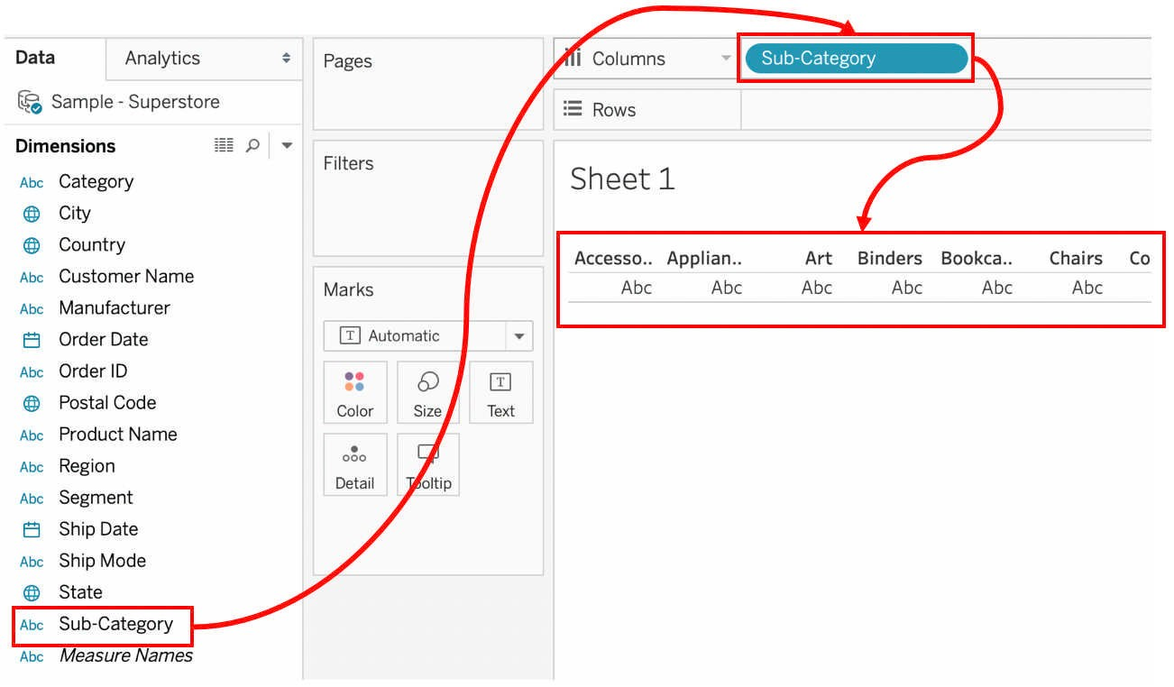

1. Tableau will automatically populate the sub-category in the Canvas. Next, drag the measure Quantity into the Row as shown in the following figure. Tableau will automatically change the visual into a horizontal bar chart as shown in the figure.

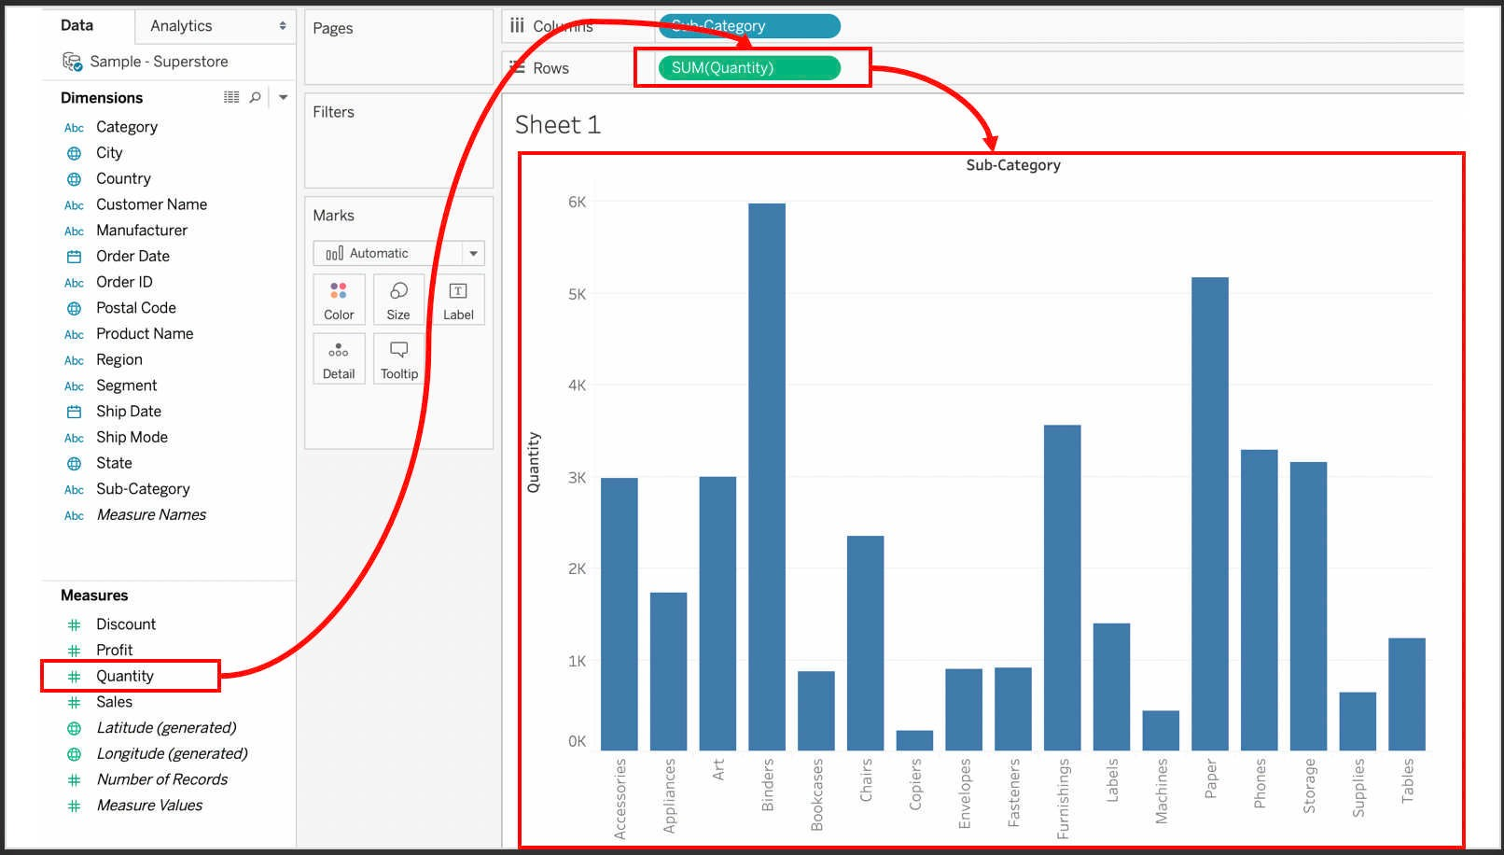

1. That complete the first method of creating a bar chart. The second method is through click-on the desired dimension and measure.
2. For this manual, the same dimension and measure is used. Double click on dimension Sub-Category and measure Quantity.

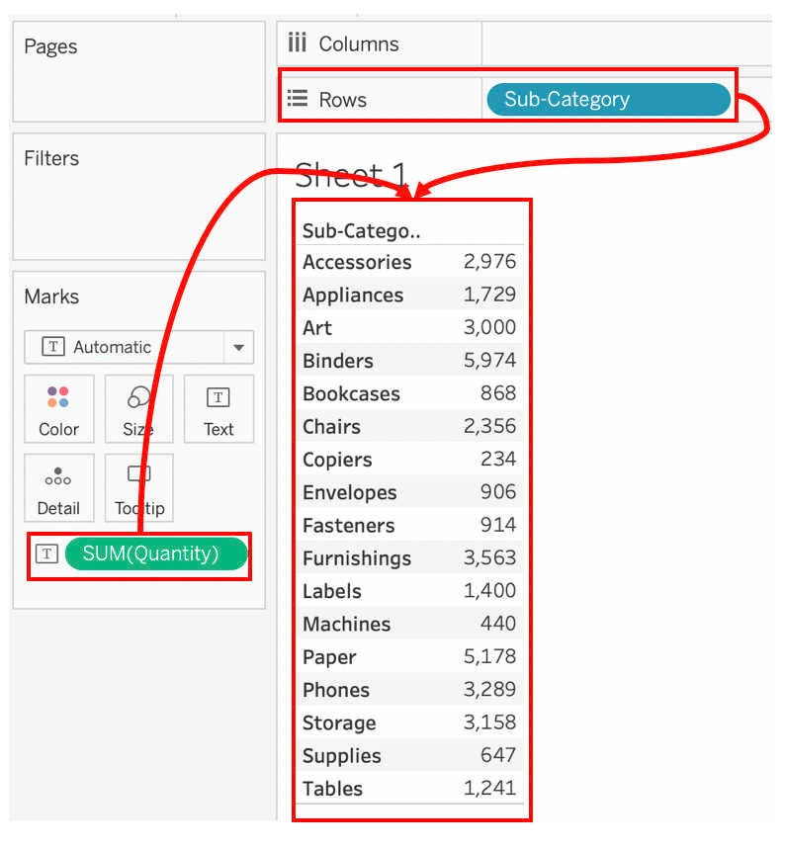

1. By default, Tableau will set the dimension to rows and measure as text value in Marks Card and the structure is grid-based similar to excel format. There are two option to convert the grid to bar chart.

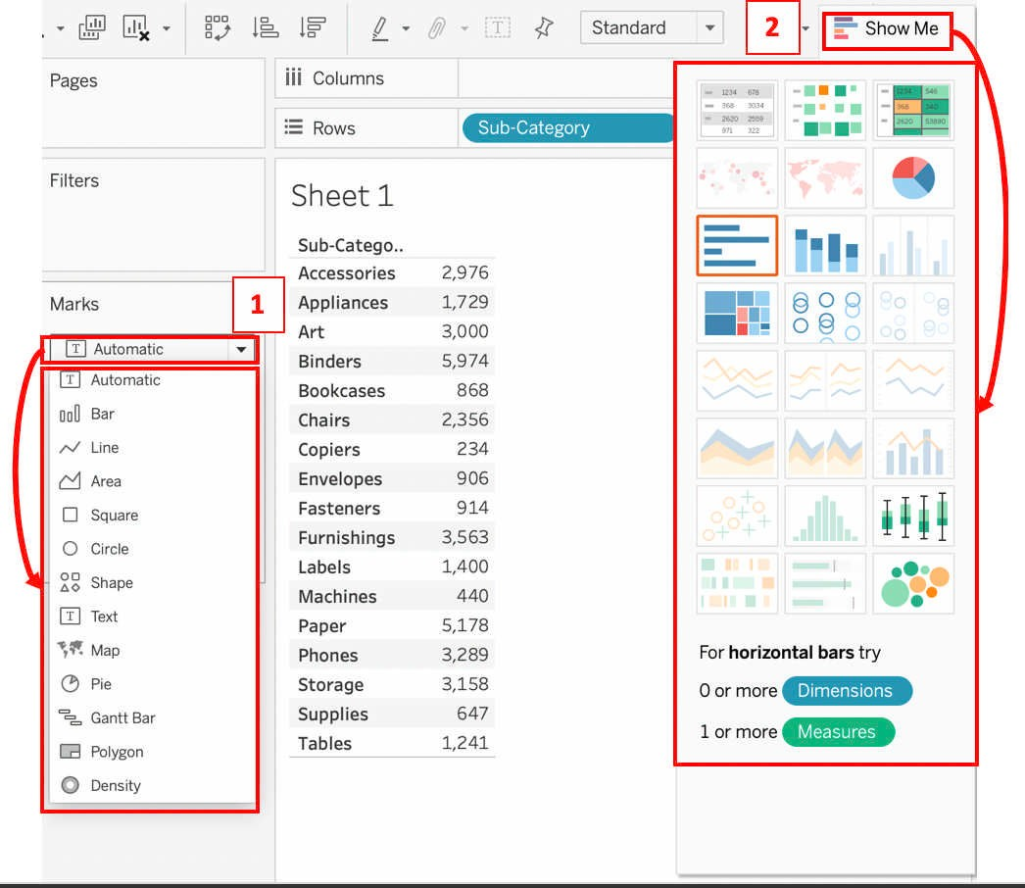

FIGURE 48: MENU TO CHANGE THE CHART

1. The first option is through the drop-down list from the Marks card, depicted as number 1 in the above figure. The second option is through drop-down list from **Show Me** icon at the toolbar, represented by number 2 in the above figure.
2. In this manual, both steps are shown. The first option is using the drop-down list from the Marks card.
3. Click drop-down list from the Marks card and choose Bar shape. Tableau will automatically change the view of grid and add a bar in the table as show in the following figure. Please take note that the bar display is small, and it is additional visual added into the grid. It is yet to be full bar chart.

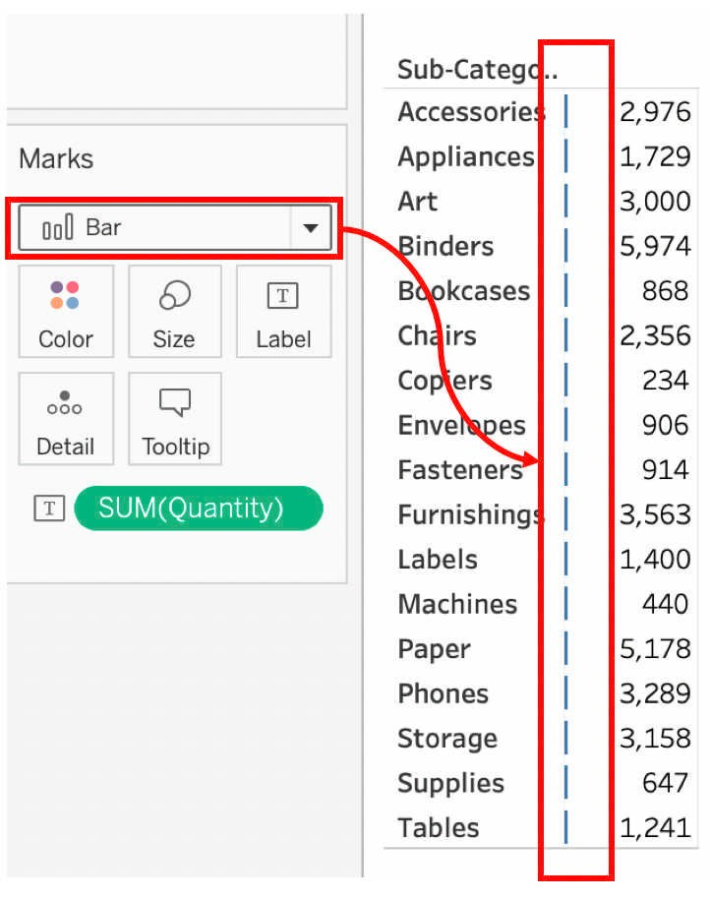

FIGURE 49: USING DROP-DOWN LIST FROM MARKS CARD FOR BAR CHART

1. As shown in previous figure, the SUM(Quantity) is set as  (label). Drag the

SUM(Quantity) into Size icon in the Marks card. Tableau will convert the visual into vertical bar chart as shown in figure below, denominated as number 1.

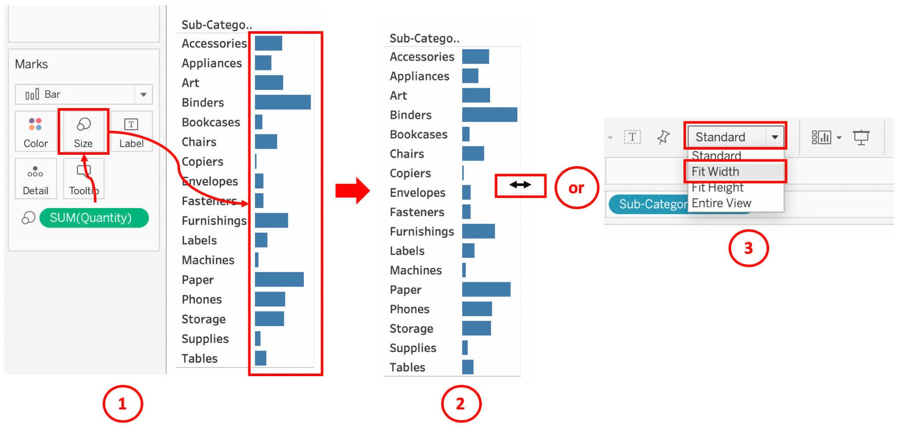

1. To resize the view of the bar, bring your mouse to the grid line until a **double-sided** arrow (your OS may show different icon) appear as denominated number 2, click (hold the mouse) and drag to resize the view to your preferred size. Alternatively, from the toolbar, change from **Standard** to **Fit Width** option, as denominated number 3 in the above figure.
2. Once you have done that, your bar chart shall be equal to vertical bar chart as shown in the following figure. Jump to Step 17 if you follow the step 11 to the step 13.
3. The second option that the user can opt to after the step 8 is through the Show Me (Chart Options) menu on the toolbar.
4. Click the Show Me button to get list of charts suitable for the data set. From the list, choose and click the vertical bar chart icon as shown in the following figure. Tableau will automatically change the view of the grid into a vertical bar chart as shown below. This is due to the category used (Sub-Category) is reside at Rows when we double-click the dimension and the selected chart option is vertical bar chart.

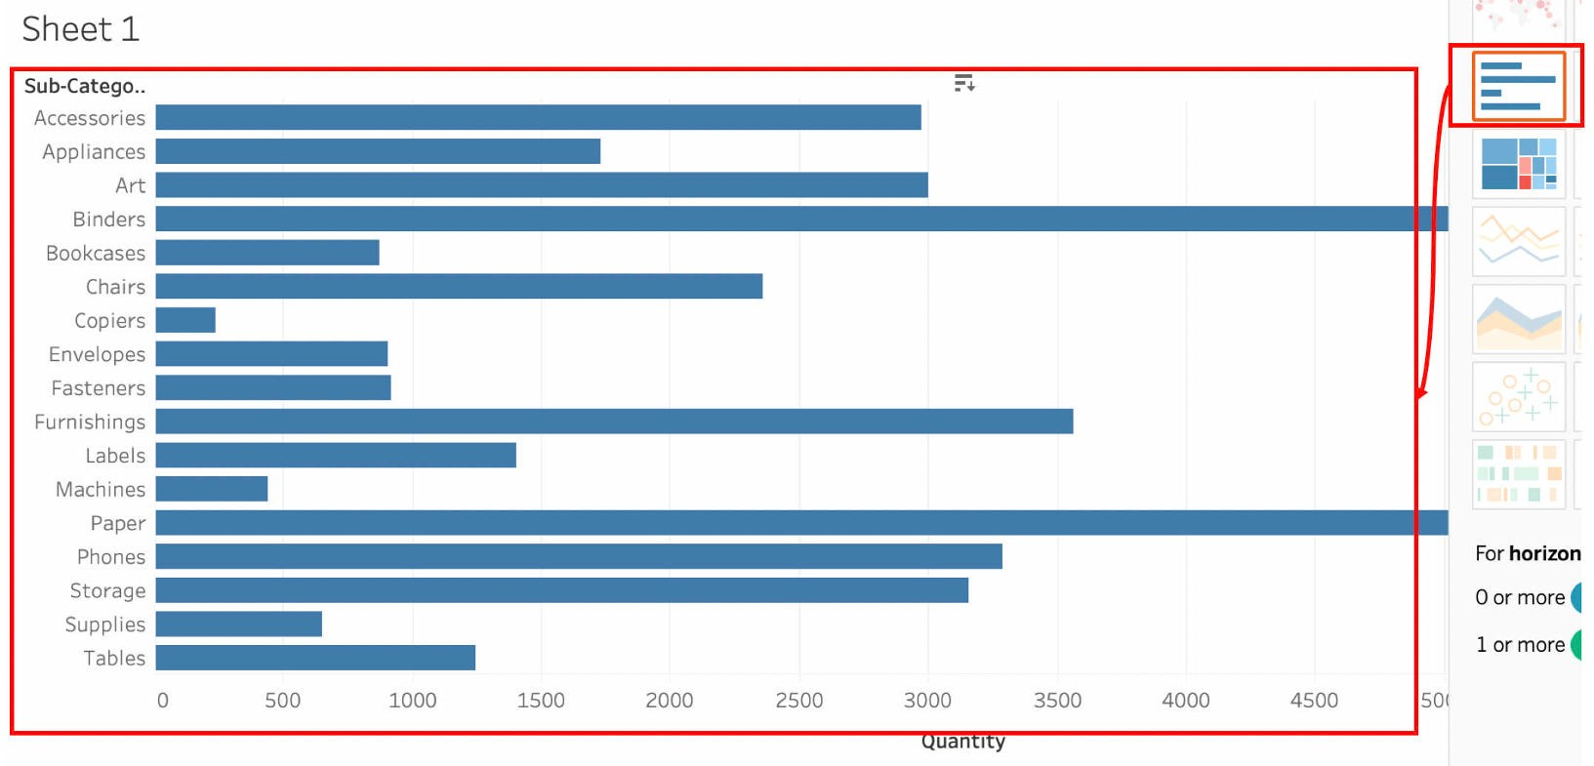

FIGURE 51: CHANGE TO BAR CHART USING THE SHOW ME FOR CHART OPTIONS

1. Finally, to get a horizontal bar chart, click on Swap Rows and Columns icon as shown in the following figure. Tableau will swap the rows and columns and change from vertical to horizontal bar chart.

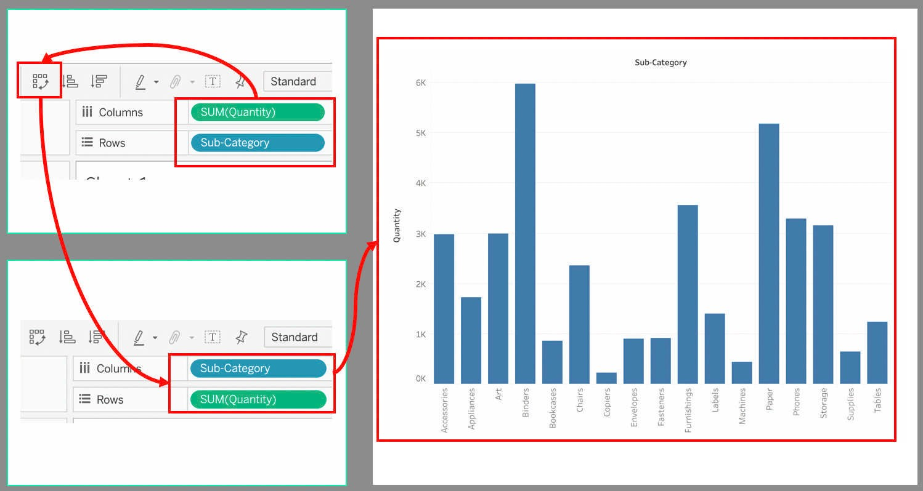

## Creating Grid Table or Table Visualization

Creating Grid Table or Table visualization in Tableau is pretty much simpler than any other visualization tool. It is just a drag and drop sequences of process. A grid table is a visual that contain a set of data displayed in a table structures that comprises at least 1 row and 1 column. There is no limit of rows and columns, it depends on the machine capacity. The following is the steps for creating Grid Table visual in Tableau.

###### Application:

* + 1. To compare between 1 or few categories. The maximum recommended is 10 categories.
    2. Suitable for multiple header data set.
    3. Suitable for dimensions that has more than 10 values.
    4. When you need to see the numbers.

###### Pre-requisite:

1. Successfully open and connect Tableau to a data source.
2. The data source contains data with proper dimensions and measures.

###### Steps:

1. Open a new sheet by click on **New Worksheet** icon at the bottom toolbar.

FIGURE 53: NEW WORKSHEET

1. In this manual, we will create a simple grid table with multiple header and data (multiple column). Double click **Category**, **Sub-Category** and **Region** dimensions, and double click **Quantity**, **Profit** and **Sales** from Measures in Data Pane.
2. Tableau will automatically populate the data into the grid, and you shall have similar visual as shown in the following figure.

FIGURE 54: AUTOMATED GRID TABLE

1. Alternatively, you can drag the dimensions and measures into the Shelves or into the Canvas.
2. If you drag the dimensions and measures into the Shelves, Tableau will automatically populate the canvas with suitable chart. In this case, it will be bar chart as shown below.

1. To change the view to Grid Table, click on Show Me icon on the toolbar and choose grid from the list of charts. Tableau shall change the visual into Grid Table as shown in figure below.

FIGURE 56: CONVERTING BAR CHART TO GRID TABLE

1. Once the grid from the list of charts is, Tableau automatically change the visual into Grid (number 1),.

## Creating Pie Chart

Pie Chart, a.k.a. circle chart, is a statistical visual in the shape of a circle. In some design, it is created like a donut (circle with empty space in the middle). The chart is divided into slices to describe the numerical values. The arc length (the degree of the slices) of each slice and consequently its central angle and area is determined by the value it holds. A bigger value will have a bigger slice arc length, of which measured in percentage (%) value. The following is the steps for creating Pie Chart in Tableau. Donut-like chart is described in Advance Tableau Manual. n

###### Application:

1. To compare a single category.
2. It is suitable for category with value less than 5. Maximum is 8. More than 8 will not be an effective visual.
3. When user prefer to see from percentage perspective.

###### Pre-requisite:

1. Successfully open and connect Tableau to a data source.
2. The data source contains data with proper dimensions and measures.

###### Steps:

1. Open a new sheet by click on **New Worksheet** icon at the bottom toolbar.
2. Similar to the creating bar chart and grid table, user has 2 options in creating the pie chart. The first is be dragging the dimension into Columns shelves and measures into Rows shelves. Column – Category, Row - QuantityThe second method is by double click the desired dimension and measure.

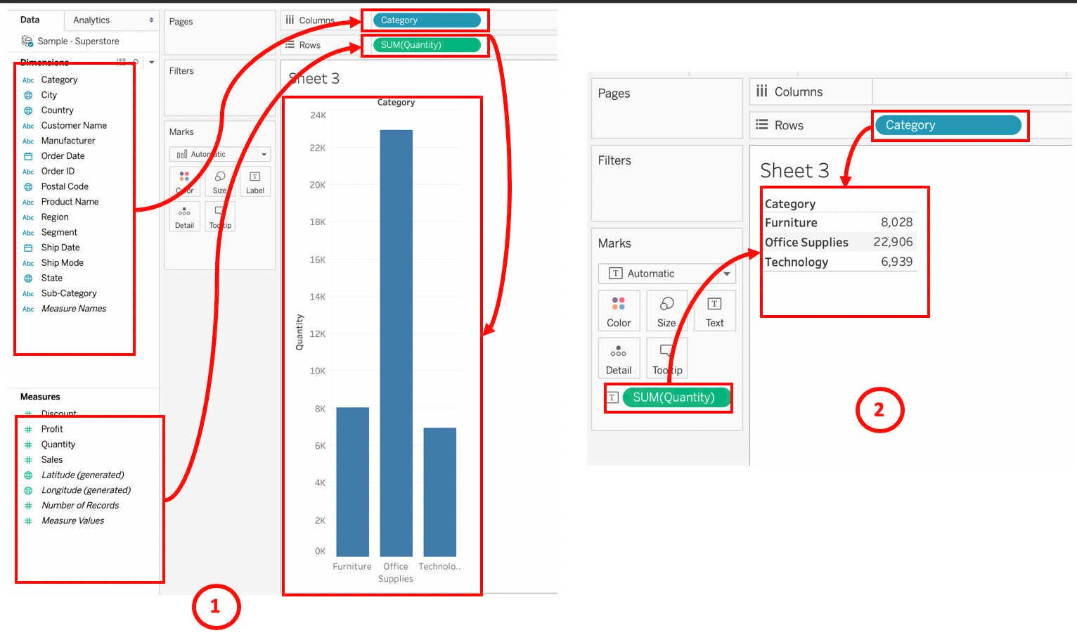

1. As shown in previous figure, number 1 shows the result of the first method (drag to shelves) to create the pie chart whereas the number 2 is the result of the second method (double-click). If user drag the dimension and measure into the canvas, Tableau will produce similar visual as the second method.
2. From the bar chart, there are 2 options to convert to pie chart. The first option is through the drop-down list on the Marks card. Click on the drop-down list and select Pie as the option similar to number 1 in the following figure. Tableau will convert the bar into circle chart as can be seen in number 2 of the same figure.

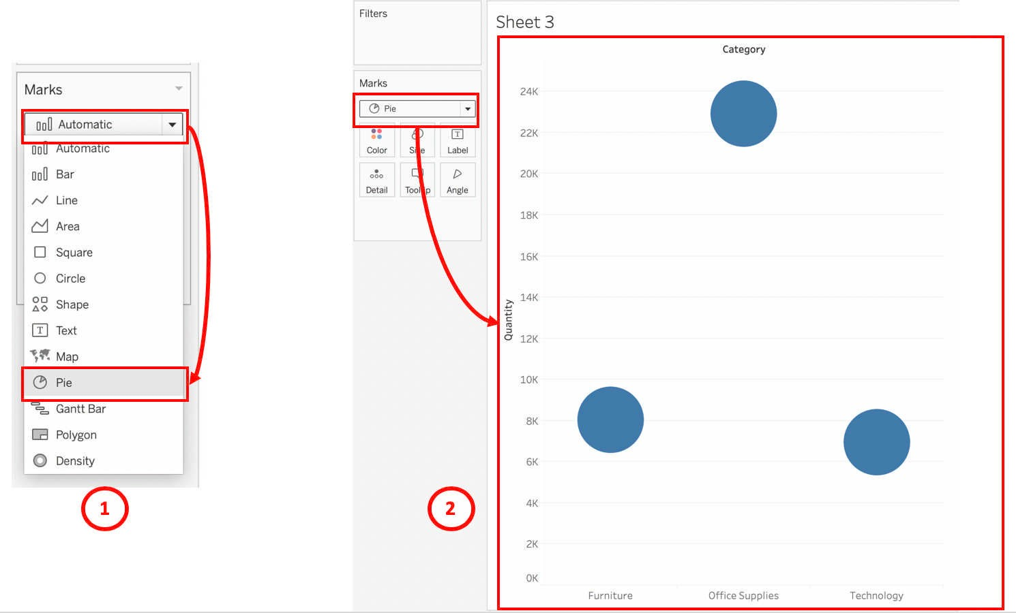

FIGURE 59: CONVERTING FROM BAR CHART TO PIE CHART - 1

1. Drag the **Category** from Column shelves into **Color** in Marks card. Tableau will change the existing circle into few colors depending on the number of data in the Category. For this manual, it is converted into 3 different colors. Then, drag the **Quantity** from Rows shelves into **Angle** in the Marks card. Tableau will change from numbers of circle into 1 pie chart. These 2 steps are shown in following figure.

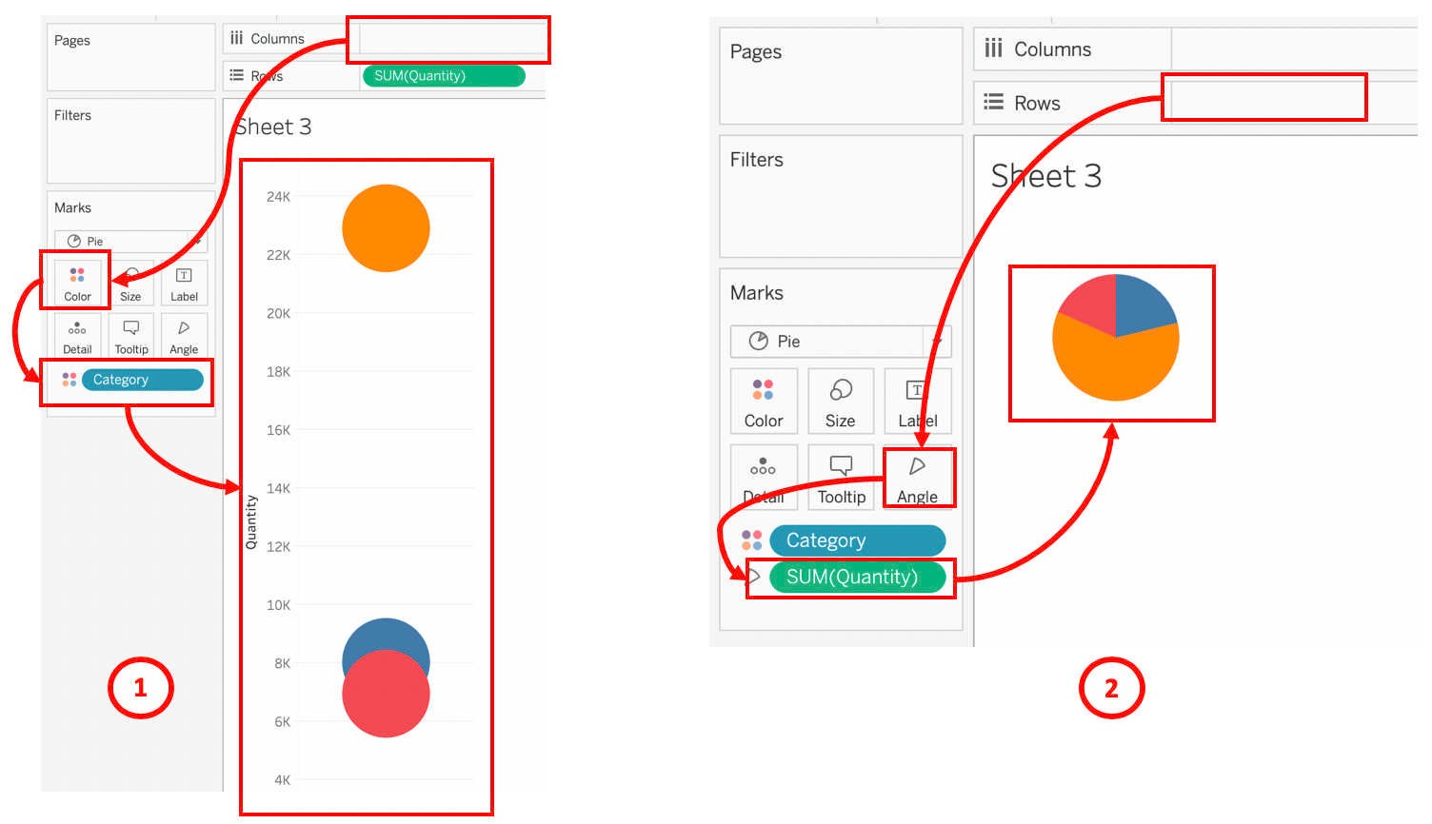

FIGURE 60: CONVERTING INTO PIE CHART - 2

1. To have meaning to the chart, simply click on Category, press button **CTRL** (or **Command**), hold the button and drag the Category into the **Label** icon in the Marks card as shown below. Repeat for SUM(Quantity). The pie chart will be labelled with the 2 values as can be seen in the figure below, represented by number 1. Click on the arrow down of the selected field (T-Sum(quantity), then choose **Quick Table Calculation** followed **by Percent of Total**, as represented by number 2 in the same figure below. Upon success, user shall be able to see a pie chart with percentage displayed similar to number 3.

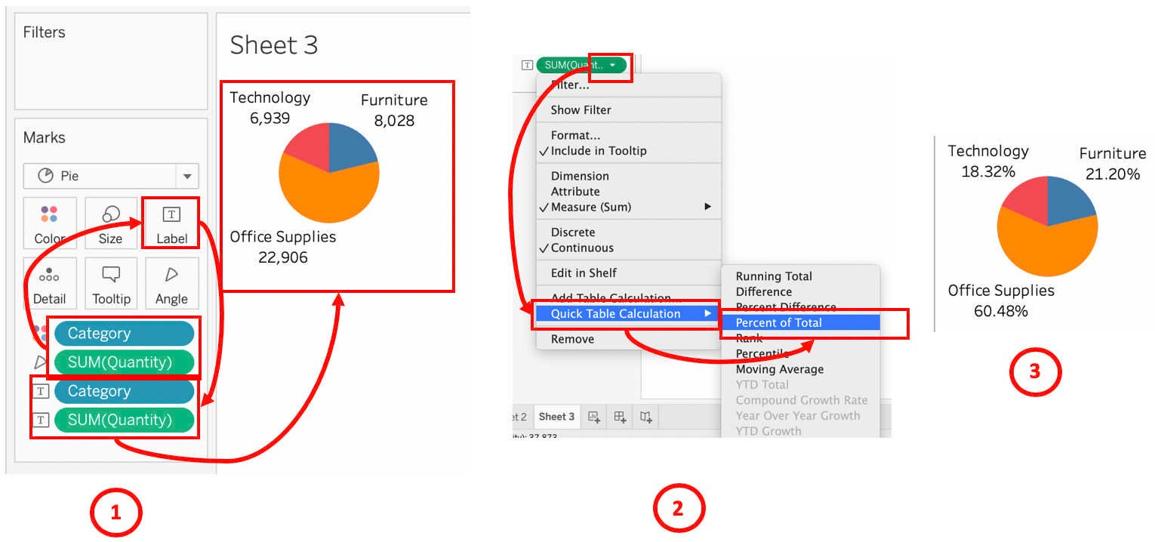

FIGURE 61: CONVERTING THE VALUE INTO PERCENTAGE FOR PIE CHART

1. User may opt for a faster approach. While at the bar chart, choose **Pie Chart** from the list of options under Show Me icon. This step is shown in the following figure.

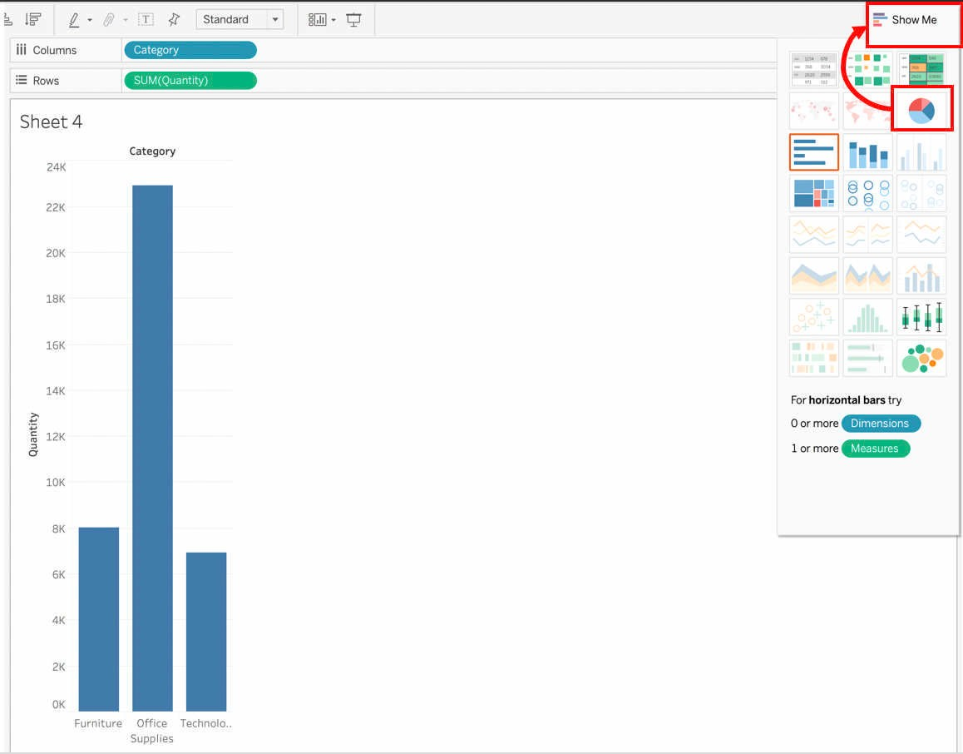

FIGURE 62: CONVERTING BAR CHART TO PIE CHART - 2

1. User shall get similar visual as shown in step 5 (represented by number 2) of this chapter. Follow the step 6 above to convert the value into percentage format.
2. From step 2, if user choose to double click the desired dimension and measure, Tableau visualize the data as a grid table. From the grid table, there are 2 options that a user can use to convert to pie chart. The first option is through Show Me button on the toolbar. The steps are similar to the above, that is start from step 8 and followed by step 6.
3. For the second option, user can select the Pie chart from the drop-down list in the Marks card. The grid table will be converted into few circles similar to the following figure.

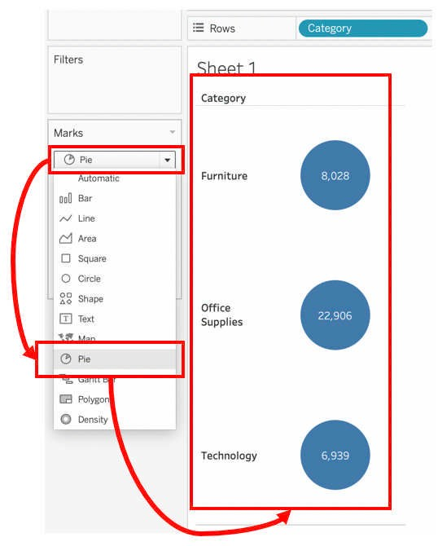

FIGURE 63: CONVERTING THE GRID TABLE TO PIE CHART - 1

1. Next, bring the Category at Rows shelves into Color in Marks card. All three circles shall be converted into a pie chart. Follow the step explained in step 6 to have a meaningful chart. Only for this time, the SUM(Quantity) shall be drag into Angle icon instead of Text.
2. Finally, the pie chart shall be similar to the pie chart shown below.

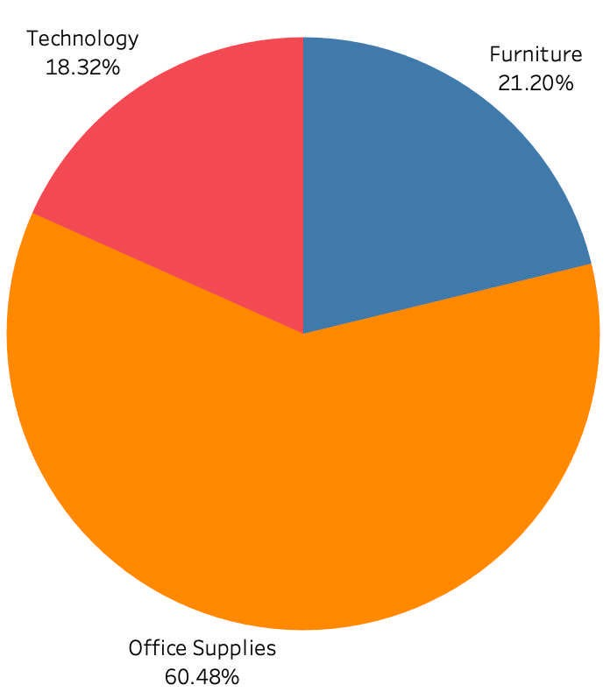

## Creating Line Chart

A line chart or line plot or line graph or curve chart is a type of chart which displays information as a series of data points called 'markers' connected by a single continuous line for each data set it represented. It is one of the most common and basic chart used to show changes of values across time. It is also known as time series chart. In a normal visual of statistical report, the horizontal axis represent time that depicts a continuous progression, while the vertical axis hold the values for a metric of interest across that progression.

Example of line chart is stock price over time, birth over time, employment rate over time, etc.

###### Application:

1. To represent a continuous data across time
2. To represent multiple data series across time (more than 5 series)
3. To represent a trend or to perform forecasting

###### Pre-requisite:

1. Successfully open and connect Tableau to a data source.
2. The data source contains data with proper dimensions and measures.
3. The dimensions include time/date data

###### Steps:

1. Open a new sheet by click on **New Worksheet** icon at the bottom toolbar.
2. Using the same data set, there are two date that can be use; that are **Order Date** and **Ship Date**. For the purpose of this manual, Order Date is used. Drag the Order Date into Columns shelves or double click the date in the Dimensions of Data pane.

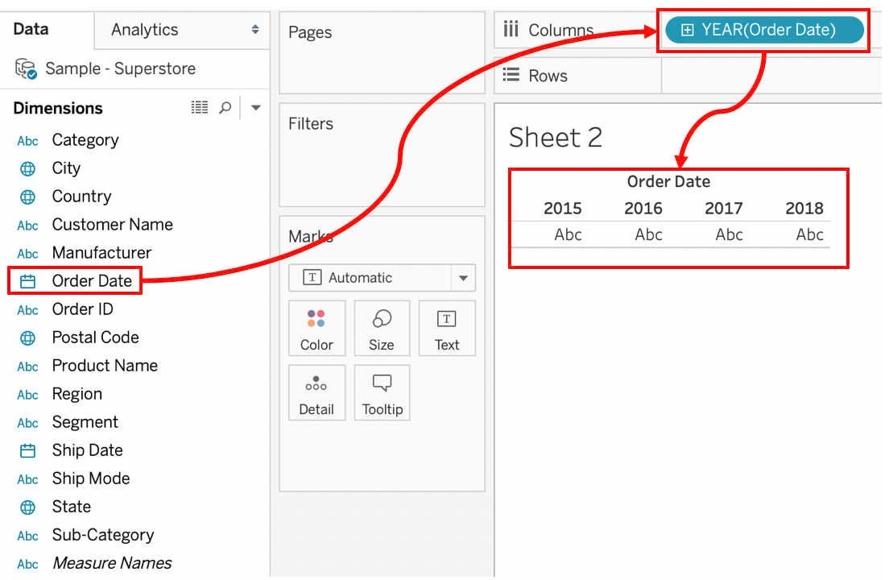

CREATING LINE CHART - DRAG ORDER DATE TO COLUMNS

70

1. Next, drag Quantity from Measures in Data pane to Rows. Tableau will automatically convert to line chart due to available time series dimension as shown in figure below.

CREATING LINE CHART - DRAG QUANTITY TO ROWS

1. Alternatively, click the Quantity or drag the quantity into the canvas. Instead of getting line chart, Tableau will visual the data as Grid similar to visual below.

CREATING LINE CHART - DOUBLE CLICK THE QUANTITY MEASURE

1. At this point, user has three methods to convert to line chart. The first method, and also the easiest and fastest is through the chart option list. Click Show Me, to get the list of chart options. There will be two lines chart that can be selected as shown below, represented by number 1, mark as letter A and B.

CREATING LINE CHART - SELECTING TYPE OF LINE CHART FROM SHOW ME

1. Based on figure above, click the option **A**. Tableau will automatically move the SUM(Quantity) from Marks card to Rows shelves and convert the grid into line chart. If user opt for option **B**, user shall be able to get similar line chart as shown in step 3 above.
2. The second method to convert the grid is by drag the SUM(Quantity) from Marks card to Rows shelves. User shall get similar line chart as shown in step 3 previously.
3. The third method, and a bit complicated, is by changing at Marks card. Click on the drop- down list of the Marks card and choose line chart. As shown in the following figure, represented by number 1 is the step taken to convert the grid into line chart. The result of the action is represented by number 2. In the same figure, labelled by character **A**, is the visual after the conversion. Noted that the line is yet to be proper and does not like like a chart yet.

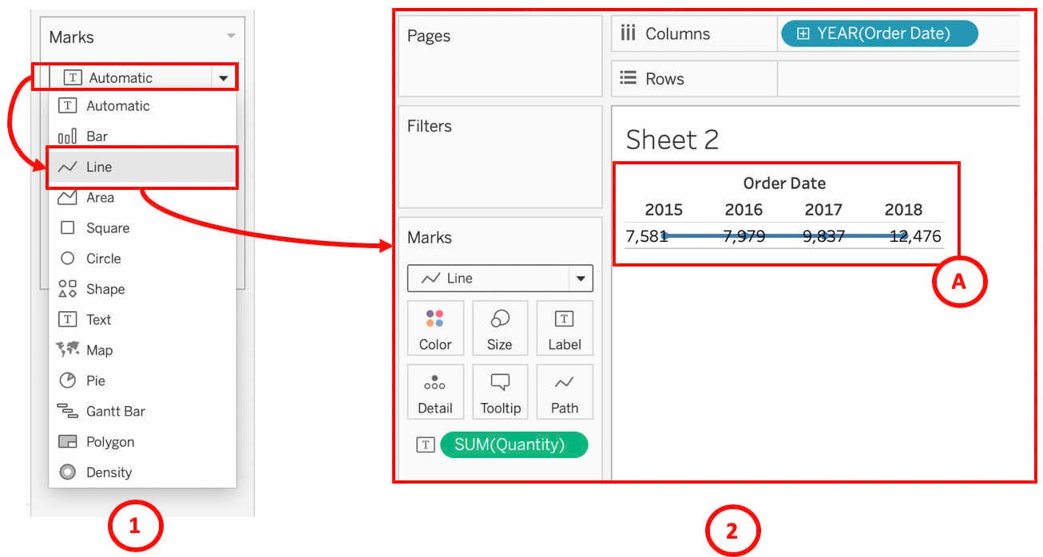

FIGURE 69: CONVERTING GRID TO LINE CHART - SELECT LINE CHART FROM DROP-DOWN LIST AT

MARKS CARD.

1. Final step for the third method is to drag SUM(Quantity) in Marks card into Rows shelves. Similar chart as shown in step 3 above can be seen upon successful.